1. Periksa kembali kenormalan rancangan basis data hasil TUBES MK APPL

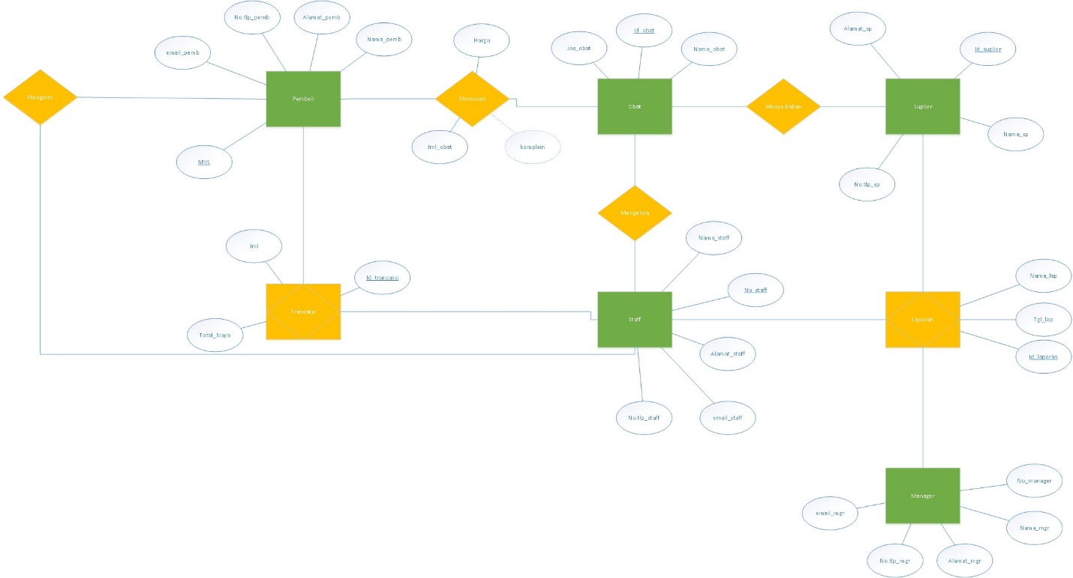Jawab :

1. Periksa kembali domain setiap atribut di setiap Tabel Basis Data TUBES APPL

Jawab :

Table 11 Tabel Pembeli

|  |  |  |
| --- | --- | --- |
| Atribut | PK / FK | Type Data |
| BPJS | PK | varchar(20) |
| nama_pemb |  | varchar(20) |
| notlp_pemb |  | varchar(15) |
| alamat_pemb |  | varchar(100) |
| email_pemb |  | varchar(20) |
| password |  | Varchar(20) |

Table 12 Tabel Suplier

|  |  |  |
| --- | --- | --- |
| Atribut | PK / FK | Type Data |
| no_suplier | PK | varchar(10) |
| nama_sp |  | varchar(20) |
| alamat_sp |  | varchar(100) |
| notlp_sp |  | varchar(15) |

Table 13 Tabel Staff

|  |  |  |
| --- | --- | --- |
| Atribut | PK / FK | Type Data |
| no_staff | PK | varchar(10) |
| nama_staff |  | varchar(20) |
| alamat_staff |  | varchar(100) |
| notlp_staff |  | varchar(15) |
| email_staff |  | varchar(20) |
| password |  | Varchar(20) |

Table 14 Tabel Manager

|  |  |  |
| --- | --- | --- |
| Atribut | PK / FK | Type Data |
| no_manager | PK | varchar(10) |
| nama_mgr |  | varchar(20) |
| alamat_mgr |  | varchar(100) |
| notlp_mgr |  | varchar(15) |
| email_mgr |  | varchar(20) |

Table 15 Tabel Obat

|  |  |  |
| --- | --- | --- |
| Atribut | PK / FK | Type Data |
| no_obat | PK | varchar(10) |
| nama_obat |  | varchar(20) |
| jenis_obat |  | varchar(20) |
| stock |  | int(10) |
| harga |  | int(10) |
| deskripsi |  | Varchar(20) |
| no_suplier | FK | varchar(10) |
| no_staff | FK | varchar(10) |

Table 16 Tabel Laporan

|  |  |  |
| --- | --- | --- |
| Atribut | PK / FK | Type Data |
| no_laporan | PK | varchar(10) |
| No_staff | FK | Varchar(10) |
| nama_laporan |  | varchar(20) |
| tanggal |  | Date |

Table 17 Tabel Transaksi

|  |  |  |
| --- | --- | --- |
| Atribut | PK / FK | Type Data |
| no_transaksi | PK | Varchar(10) |
| No_staff | FK | Varchar(10) |
| Jumlah_obat |  | int(10) |
| total_harga |  | int(10) |
| harga_obat |  | int(10) |
| Tanggal_transaksi |  | Date |

Table 18 Tabel Pemesanan

|  |  |  |
| --- | --- | --- |
| Atribut | PK / FK | Type Data |
| Id_pesanan | PK | varchar(10) |
| BPJS | FK | varchar(20) |
| no_transaksi | FK | Varchar(10) |
| Jumlah_obat |  | int(10) |
| Total_harga |  | int(10) |
| Tanggal_pemesanan |  | Date |

Table 19 Tabel Detail Pemesanan

|  |  |  |
| --- | --- | --- |
| Atribut | PK / FK | Type Data |
| Id_pesanan | FK | varchar(10) |
| No_obat | FK | varchar(10) |

Table 20 Tabel Detail Laporan

|  |  |  |
| --- | --- | --- |
| Atribut | PK / FK | Type Data |
| no_laporan | FK | varchar(10) |
| no_manager | FK | varchar(10) |

1. Periksa kembali Primary Key – Foreign Key di rancangan basis Data TUBES APPL anda

Jawab :

|  |  |  |  |  |  |
| --- | --- | --- | --- | --- | --- |
| Nama Tabel | Jenis | Volume | Laju | Primary Key | CI/Foreign Key |
| Tabel Pembeli | Tabel Master | - | - | BPJS | Staff(no_staff) |
| Tabel Suplier | Tabel Master | - | - | no_suplier | - |
| Tabel Staff | Tabel Master | - | - | no_staff | - |
| Tabel Manager | Tabel Master | - | - | no_manager | - |
| Tabel Transaksi | Tabel Relasi | - | - | no_transaksi | Pemesanan(id_pesanan)  Staff(no_staff) |
| Tabel Obat | Tabel Master | - | - | no_obat | Suplier(no_suplier)  Staff(Id_staff) |
| Tabel Laporan | Tabel Relasi | - | - | no_laporan | Staff(no_staff) |
| Tabel Detil Pemesanan | Tabel Relasi | - | - | - | Pemesanan(id_pesanani), Obat(no_obat) |
| Tabel Pemesanan | Tabel Relasi | - | - | id_pesanan | Pembeli(BPJS)  Transaksi(no_transaksi) |
| Tabel Detil Laporan | Tabel Relasi | - | - | - | Laporan(id_laporan), Manager(no_manager) |

1. Pilih salah satu tabel dari rancangan basis data anda buat perintah SQL untuk membuatnya.